Full Blank Review Questions 2019
26 November 2019
16:14

How to get the most out of these questions
- Don't try and do them all at once! There are a lot of questions, make notes, write the first thing that comes to mind and just start.
- Come back repeatedly. Over the break between Christmas and New Year or before if you are excited come back lots of times and answer a few questions, re-read your answers and add to it. You will be in a different state each time you write and this will give you a more complete perspective and better answers
- Take time and think. One of the most important aspects of this exercise is that it makes you think, enjoy the thinking process and have fun with it. Take your time and enjoy it
- Do them however it works for you. Print them out, write them out in a journal, type the answers into OneNote like Katie and I do! Whatever works for you to work through them and answer them
- Put a little check box next to any actions you think you should take that come to you as you write. Then at the end go through and collect all the actions. This is going to give you some good ideas and thoughts to get started in the new year.
- Don't censor yourself. People kill their own ideas. When you get to the questions about what you want to do in 2020 don't censor yourself by saying "That isn't possible" and not write it. Write all the ideas down even if they seem crazy. You don't have to know how to make them happen yet!

Have fun writing in your journal and exploring your ideas. It is amazing what comes out of this exercise!

What's been the best and why?
What are you most proud of this year? What have you created? Bought into life? Done? Experienced? What are the things you are most proud of from this last year?

What did these achievements or actions make possible? For you, for your family, for your business? For your financial situation or health and wellbeing? Why were they so important to you?

What makes your heart warm just to think about it today?

What's been the most fun so far this year? When did you have the biggest laugh?

What’s been the toughest?

What event or experience represented the “worst” of the year? Why was it so bad?

What actions did you take that you aren't proud of? What do you want to eradicate from your behaviour from last year?

What makes you feel “less than,” ashamed or even toxic to others?

Who have you least enjoyed working with?

What do I need to kill off?

Where have I stayed stuck?

What should I subtract from my life to improve it?

What problems have I encountered?

How can I throw money at this problem? How can I “waste” money to improve the quality of my life?

Looking at the different areas of your life - reflection

Where am I now? For the wheel below take a pen and colour in the circle segments with where you would rate yourself currently. Each segment is a scale of ten so if you think you are currently a 6 on Health and Fitness mark that in. This exercise gives you a visual representation of how you are doing on life’s different areas!

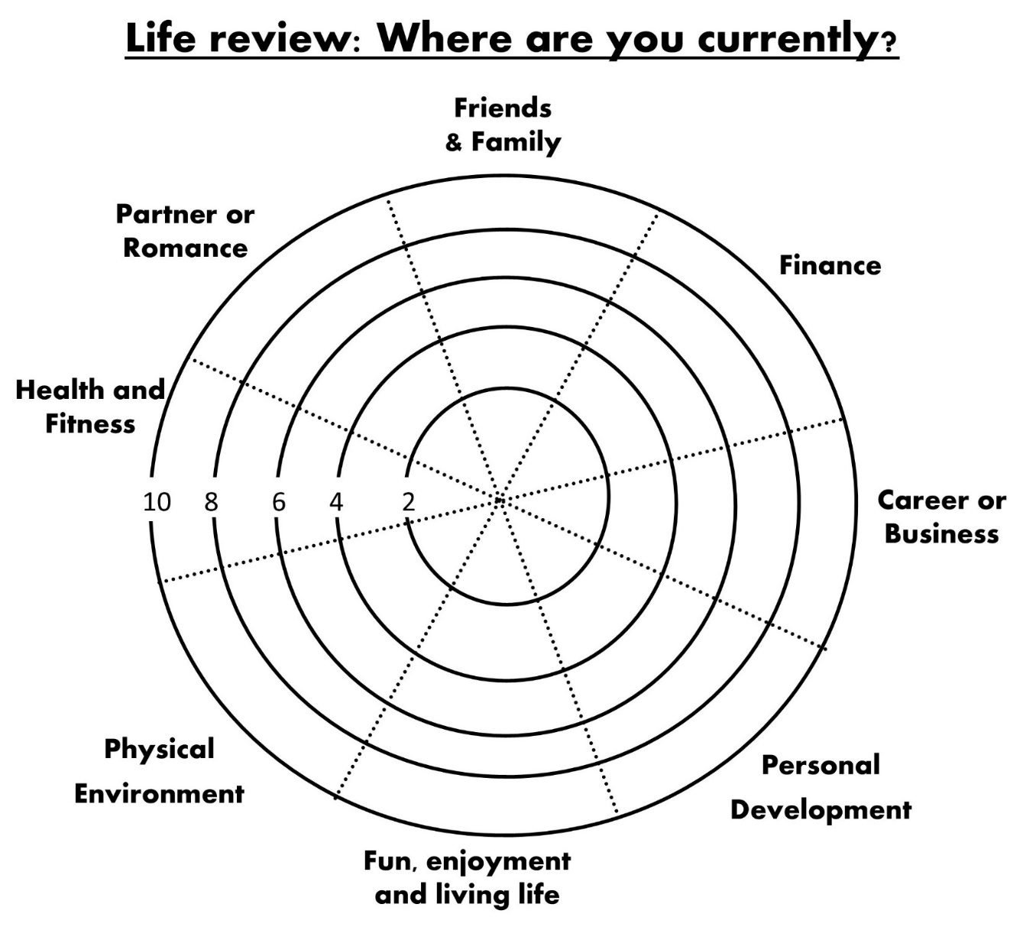

Comment on the progress, status and review each of the major areas of your life

- Finance and money

- Business and Career
  - Human Resources
  - Marketing and Promotion
  - Sales
  - Customer Service
  - Money - Accounting and Finance
  - Legal Documentation - up to date?
  - Purchasing
  - Distribution
  - R&D - improving things
  - Production
  - Administration and management
  - Operations
  - IT

- Relationships

- Health and Wellness

- Recreation and Play

- Education

- Service and Contribution

What shall we build on next year? What shall we amplify?

What outcomes or achievements do you want to build on next year?

What would I do/have/be if I had £10 million in the bank?

What parts of yourself do you wish to expand and strengthen, and let out in the world?

What role models and supportive people do you want to connect with more deeply?

What do you want to do more of this year coming?

If you had the best year EVER what would have happened?

What most excites you about 2020?

Who has been most helpful?

Who are the top three helpers whom you’d like to knowledge? And why…………

Who has gone above and beyond in their efforts to assist you in a goal or important outcome?

Who do I want to meet in 2020? Who do I want to spend more time with in 2020?

What are your top priorities?

What priorities did you honour well so far this year?

What priorities did you neglect or turn your back on?

What new values and priorities have emerged for you this year that you are committed to honouring?

What if I did the opposite?

If I could only spend 2 hours a week working on my business what would I do?

Am I hunting antelope or field mice? Look at my to do list and ask “Which one of these, if done, would render all the rest either easier or completely irrelevant?” What is the lead domino for my biggest life goals? (Tim Ferriss Question)

Other Questions

If you could only stop one thing, what’s that one thing?
Write a paragraph or two about options of things you could stop (Divergent thinking) and then narrow it down to the answer about what is the 1 thing (Convergent Thinking)

What should I subtract or remove from my life to improve it?

If you could only double down on one thing, what’s that?
Write a paragraph or two about options of things you could double down on (Divergent thinking) and then narrow it down to the answer about what is the 1 thing (Convergent Thinking)

If you could only start one thing, would we you begin?
Write a paragraph or two about options of things you could double down on (Divergent thinking) and then narrow it down to the answer about what is the 1 thing (Convergent Thinking)

What are your biggest goals?

What excites you most about the future?

Who do you want to become in 2020? Describe the person you want to become……..

What training or development do you want to do in 2020 to help you become the above person?

